Lab Exercise 1 – 4 ARP

Objective
To see how ARP (Address Resolution Protocol) works. ARP is an essential glue protocol that is used to join Ethernet and IP. Review that section before doing this lab.
Requirements
Wireshark: This lab uses the Wireshark software tool to capture and examine a packet trace.
arp: This lab uses the “arp” command-line utility to inspect and clear the cache used by the ARP protocol on your computer. arp is installed as part of the operating system on Windows, Linux, and Mac computers, but uses different arguments. It requires administrator privileges to clear the cache.
Ifconfig / ipconfig: This lab uses the “ipconfig” (Windows) or “ifconfig” (Mac/Linux) command-line utility to inspect the state of your computer’s network interface. ifconfig/ipconfig is installed as part of the operating system on Windows, Linux, and Mac computers.
route / netstat: This lab uses the “route” or “netstat” command-line utility to inspect the routes used by your computer. A key route is the default route (or route to prefix 0.0.0.0) that uses the default gateway to reach remote parts of the Internet. Both “route” and “netstat” are installed as part of the operating system across Windows and Mac/Linux, but there are many variations on the command-line parameters that must be used.
Browser: This lab uses a web browser to find or fetch pages as a workload. Any web browser will do.
Turn in
Hand in the trace file you captured and exercise report including your answers to the questions and figures you drew.
Step 1: Capture a Trace
- Find the Ethernet address of the main network interface of your computer with the ifconfig / ipconfig command. You will want to know this address for later analysis. On Windows, bring up a command-line shell and type “ipconfig /all”. On Mac/Linux, bring up a command-line shell and type “ifconfig”. Among the output will be a section for the main interface of the computer (likely an Ethernet interface) and its Ethernet address.
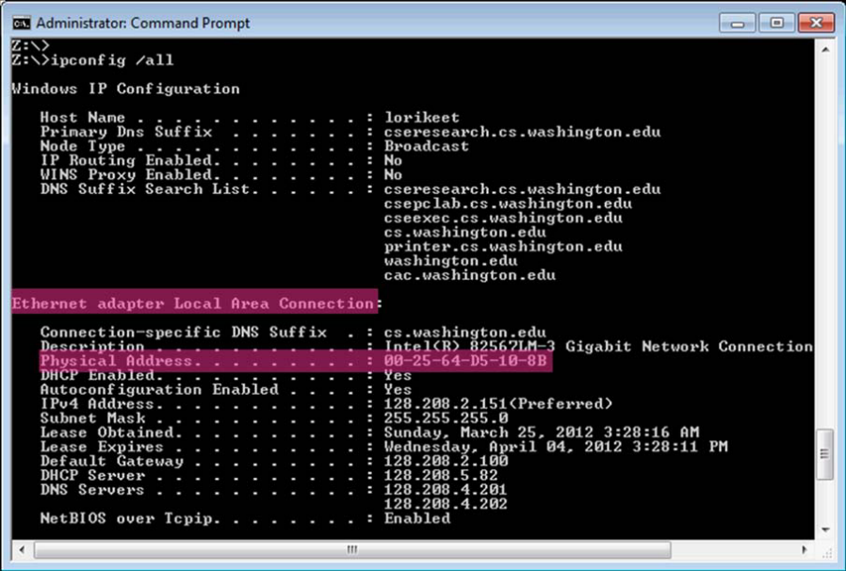
Figure 1: Finding the computer's Ethernet address with ipconfig (Windows)
- Find the IP address of the local router or default gateway that your computer uses to reach the rest of the Internet using the netstat / route command. You should be able to use the netstat command (“netstat –r” on Windows, Mac and Linux, may require ctrl-C to stop). Alternatively, you can use the route command (“route print” on Windows, “route” on Linux, “route –n get default” on Mac). In either case you are looking for the gateway IP address that corresponds to the destination of default or 0.0.0.0. Example is shown below for netstat, with our added highlighting.
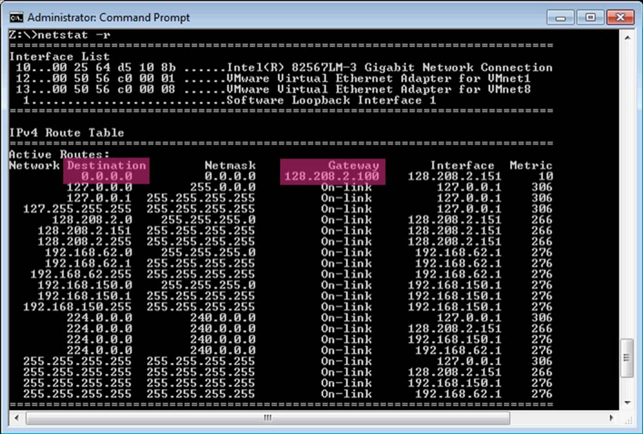
Figure 2: Finding the default gateway IP address with netstat (Windows)
- Launch Wireshark and start a capture with a filter of “arp“. Your capture window should be similar to the one pictured below, other than our highlighting. Select the interface from which to capture as the main wired or wireless interface used by your computer to connect to the Internet. If unsure, guess and revisit this step later if your capture is not successful. Uncheck “capture packets in promiscuous mode”. This mode is useful to overhear packets sent to/from other computers on broadcast networks. We only want to record packets sent to/from your computer. Leave other options at their default values. The capture filter, if present, is used to prevent the capture of other traffic your computer may send or receive. On Wireshark 1.8, the capture filter box is present directly on the options screen, but on Wireshark 1.9, you set a capture filter by double-clicking on the interface.
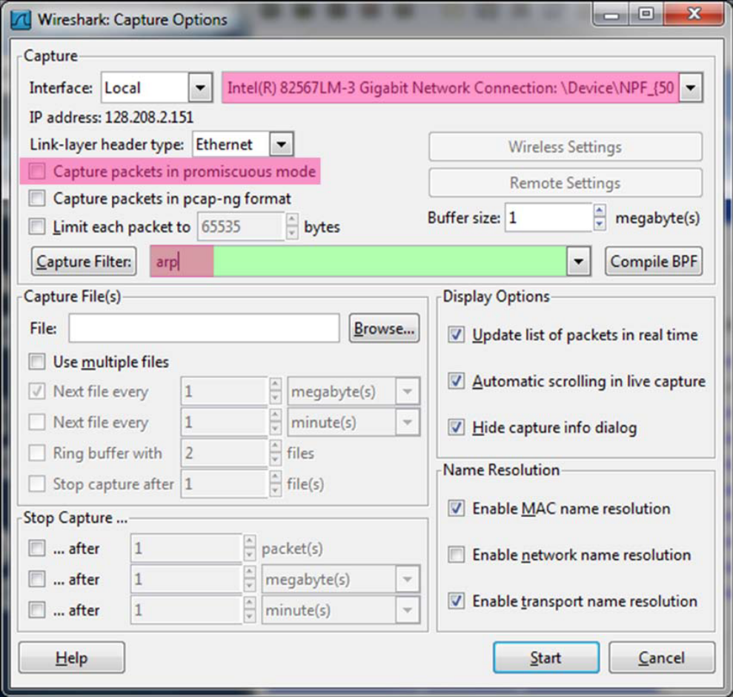
Figure 3: Setting up the capture options
- When the capture is started, use the “arp” command to clear the default gateway from the ARP cache. Using the command “arp –a” will show you the contents of the ARP cache as a check that you can run “arp”. You should see an entry for the IP address of the default gateway. To clear this entry, use the arp command with different arguments (“arp –d” on Windows, “arp –d –a” on Mac, “arp –d xx.xx.xx.xx” where xx.xx.xx.xx is the IP address of the default gateway on Linux). This usage of arp will need administrator privileges to run, so you may run as a privileged user on Windows or issue “sudo arp –d xx.xx.xx.xx” on Linux/Mac. Note that the command should run without error but the ARP entry may not appear to be cleared if you check with “arp –a”. This is because your computer will send ARP packets to repopulate this entry as soon as you need to send a packet to a remote IP address, and that can happen very quickly due to background activity on the computer.
- Now that you have cleared your ARP cache, fetch a remote page with your Web browser. This will cause ARP to find the Ethernet address of the default gateway so that the packets can be sent. These ARP packets will be captured by Wireshark. You might clear the ARP cache and fetch a document a couple of times. Hopefully there will also be other ARP packets sent by other computers on the local network that will be captured. These packets are likely to be present if there are other computers on your local network. In fact, if you have a busy computer and extensive local network then you may capture many ARP packets. The ARP traffic of other computers will be captured when the ARP packets are sent to the broadcast address, since in this case they are destined for all computers including the one on which you are running Wireshark. Because ARP activity happens slowly, you may need to wait up to 30 seconds to observe some of this background ARP traffic.
- Once you have captured some ARP traffic, stop the capture. You will need the trace, plus the Ethernet address of your computer and the IP address of the default gateway for the next steps.
Step 2: Inspect the Trace
Now we can look at an ARP exchange! Since there may be many ARP packets in your trace, we’ll first narrow our view to only the ARP packets that are sent directly from or to your computer.
Set a display filter for packets with the Ethernet address of your computer. You can do this by entering an expression in the blank “Filter:” box near the top of the Wireshark window and clicking “Apply”. The filter to enter depends on your Ethernet address. For example, if your Ethernet address is 01:02:03:04:05:06 then enter a filter expression of “eth.addr==01:02:03:04:05:06”. After applying this filter your capture should look something like the figure below, in which we have expanded the ARP protocol details.
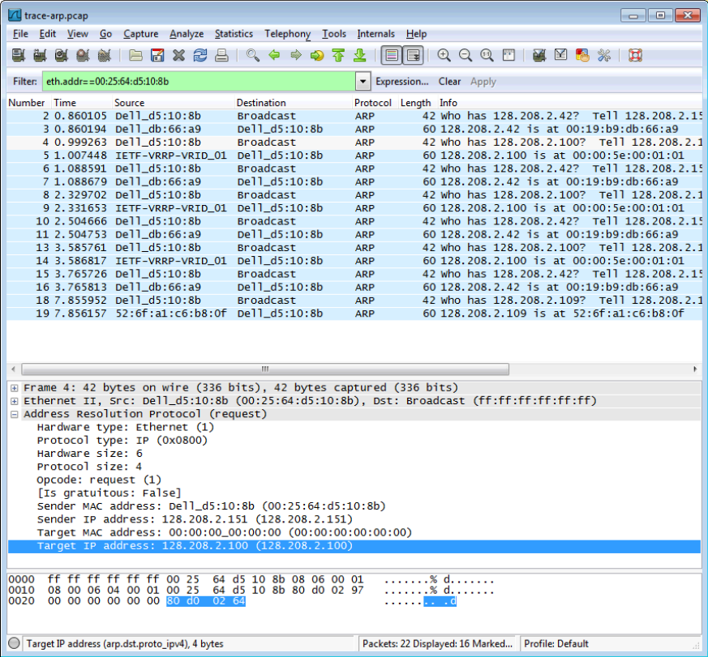
Figure 4: Capture of ARP packets, showing details of a request
Find and select an ARP request for the default gateway and examine its fields. There are two kinds of ARP packets, a request and a reply, and we will look at each one in turn. The Info line for the request will start with “Who has …”. You want to look for one of these packets that asks for the MAC address of the default gateway, e.g., “Who has xx.xx.xx.xx …” where xx.xx.xx.xx is your default gateway. You can click on the + expander or icon for the Address Resolution Protocol block to view the fields.
Next, select an ARP reply and examine its fields. The reply will answer a request and have an Info line of the form “xx.xx.xx.xx is at yy:yy:yy:yy:yy:yy”.
Step 3: ARP request and reply
To show your understanding of an ARP exchange, draw a figure that shows the ARP request and reply packets sent between your computer and the default gateway. Make it for the case we examined of your computer doing an ARP for the default gateway. Label one packet the request and the other the reply. Give the sender and target MAC and IP addresses for each packet; you can use Wireshark to inspect the packets to get these values. Finally, circle the sought after Ethernet address on your drawing to show where it comes from in the exchange.
Step 4: Details of ARP over Ethernet
To look at further details of ARP, examine an ARP request and ARP reply to answer these questions:
- What opcode is used to indicate a request? What about a reply?
Answer:
Opcode: Request – 1
Reply - 2

- How large is the ARP header for a request? What about for a reply?
Answer:
Request: 28 Bytes.
Reply: 28 Bytes.

- What value is carried on a request for the unknown target MAC address?
Answer:
For Broadcast, the value is 18 Bytes’ 0.

ARP packets are carried in Ethernet frames, and the values of the Ethernet header fields are chosen to support ARP. For instance, you may wonder how an ARP request packet is delivered to the target computer so that it can reply and tell the requestor its MAC address. The answer is that the ARP request is (normally) broadcast at the Ethernet layer so that it is received by all computers on the local network including the target. Look specifically at the destination Ethernet address of a request: it is set to ff:ff:ff:ff:ff:ff, the broadcast address. So the target receives the request and recognizes that it is the intended recipient of the message; other computers that receive the request know that it is not meant for them. Only the target responds with a reply. However, anyone who receives an ARP packet can learn a mapping from it: the sender MAC and sender IP pair.
Examine an ARP request and reply to answer these questions:
- What Ethernet Type value which indicates that ARP is the higher layer protocol?
Answer: ARP 0x0806

- Is the ARP reply broadcast (like the ARP request) or not?
Answer:
No. It will be sent to the sender.

Explore on your own
We encourage you to explore ARP on your own once you have completed this lab. One suggestion is to look at other ARP packets that may have been recorded in your trace; we only examined an ARP request by your computer and the ARP reply from the default gateway.
To see if there is other ARP activity, make sure to clear any Ethernet address filter that is set. Other ARP packets may exhibit any of the following kinds of behavior for you to explore:
- ARP requests broadcast by other computers. The other computers on the local network are also using ARP. Since requests are broadcast, your computer will receive their requests.
- ARP replies sent by your computer. If another computer happens to ARP for the IP address of your computer, then your computer will send an ARP reply to tell it the answer.
- Gratuitous ARPs in which your computer sends a request or reply about itself. This is helpful when a computer or link comes up to make sure that no one else is using the same IP address. Gratuitous ARPs have the same sender and target IP address, and they have an Info field in Wireshark that identified them as gratuitous.
- Other ARP requests sent by your computer and the corresponding ARP reply. Your computer may need to ARP for other hosts besides the default gateway after you flush its ARP cache.

